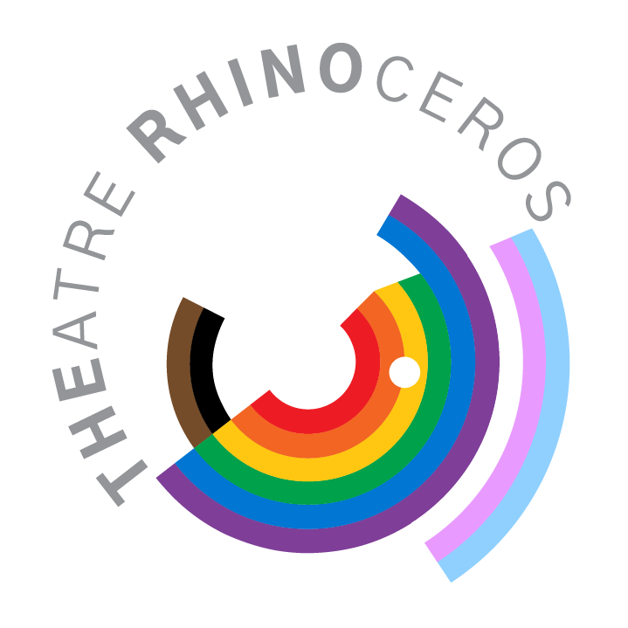

For Immediate Release: Theatre
Contact: Crystal Liu, Office Manager
650-475-6685 (do not publish this number) or cliu@therhino.org
Available for interviews / high-res pics at http://therhino.org/press-room/

Theatre Rhinoceros Presents
Porcelain: A Free Staged Reading
Chay Yew’s provocative 1992 play breathes again with new urgency
December 13, 2022

November 30, 2022, San Francisco - Written by acclaimed Singaporean-born playwright and director Chay Yew (A Language of their Own, Wonderland), Porcelain is an examination of a young man's crime of passion. Triply scorned — as an Asian, a homosexual, and now a murderer — Chinese 19 year-old John Lee has confessed to shooting his Caucasian lover in a public lavatory in London. The play dissects the crime through a prism of conflicting voices: newscasts, flashbacks, and John's own recollections to a prison psychiatrist.

Through the biting, alternative darkness of Yew’s work, one can see the emergence of a queer Asian consciousness and inner turmoil that is rarely presented on today’s Western stages. For those paying attention, there has been a definite shift in American live theatre to showcase celebratory displays of Asian culture (see: the recent Broadway premiere of KPOP, the push for AAPI actors to fill conventionally white roles locally and nationally, and the gradual integration of original AAPI-centered and -led works into local theatre seasons), especially in response to the rise of anti-Asian violence in the United States. It is so much more important then, to understand and honor what Chay Yew himself called “the dark side” of living as an Asian person today, especially a queer Asian person, in a Western colonial society - to honor what is painful, unsettling, and non-conforming about the shared experiences of Asian-ness and queer-ness, as well as that which we are told is beautiful, familiar, and exemplary.

“In the core of this provocative, bold drama is a question of identity, belonging and otherness, as well as an exploration of love and connection,” says Ely Sonny Orquiza, the multidisciplinary director of the reading. “What I love most about Porcelain is Yew's genius blend of poetry, imagery, and cultures that has forced me to continually reflect about the progress of the queer movement — or lack thereof— in respect to the Asian community. I'm particularly curious how the Bay Area will receive this piece, especially being in the heart of the Castro Neighborhood.”

Porcelain: A Free Staged Reading is directed by Orquiza and performed by a cast of Bay Area actors at Theatre Rhinoceros, the longest-running LGBTQ+ theatre in the world.

Calendar Editors

What: Porcelain: A Free Staged Reading

When: Tuesday, December 13 at 7pm

Where: Theatre Rhinoceros, 4229 18th St., San Francisco, CA 94114
Castro Street MUNI Station; F Market, 33 Stanyan, 24 Divisadero
Streetcar and Bus Lines

Tickets: Free

Info / Res: https://therhino.org/ or https://fb.me/e/2PAhoSmyz

Presented in San Francisco as a staged reading 30 years after its London premiere, Porcelain by Chay Yew is an examination of a young man's crime of passion. Triply scorned — as an Asian, a homosexual, and now a murderer — Chinese 19 year-old John Lee has confessed to shooting his Caucasian lover in a public lavatory in London. Amidst a modern political, racial climate more hostile and divisive than ever, Porcelain reminds us that in all our shared humanity lies the potential for violence alongside love. Porcelain: A Free Staged Reading is directed by artist, director, and educator Ely Sonny Orquiza, and performed by Mikee Loria, Walter Zarnowitz, Faustino Cadiz, Alec Braun, and Max Seijas.

Hi-res Digital Images Available for Download at: http://therhino.org/press-room/

The Artists

Chay Yew is an acclaimed playwright and director. As a playwright, his plays include Porcelain, A Language of Their Own, Red, Wonderland, Question 27 Question 28, A Distant Shore, 17, and Visible Cities. For his plays, he is the recipient of the London Fringe Award for Best Playwright and Best Play, among many others. Most recently, he directed Lauren Yee’s Cambodian Rock Band (South Coast Rep, Oregon Shakespeare Festival, La Jolla Playhouse).

Ely Sonny Orquiza is a multidisciplinary Queer Filipino artistic director, stage director, and teaching artist based in San Francisco Bay Area. Through theater and the performing arts Orquiza explores the role of the Asian diaspora, Asian American experience, ancestral ghosts, and the politics of Queer/ness for the American stage. He is a Co-Founder and Co-Artistic Director of The Chikahan Company, a new Filipinx theater company based in San Francisco.

Mikee Loria portrays “John” in Porcelain: A Free Staged Reading.

Walter Zarnowitz portrays “Voice One” in Porcelain: A Free Staged Reading.

Faustino Cadiz portrays “Voice Two” in Porcelain: A Free Staged Reading.

Alec Braun portrays “Voice Three” in Porcelain: A Free Staged Reading.

Max Seijas portrays “Voice Four” in Porcelain: A Free Staged Reading.

Theatre Rhinoceros was founded in 1977, and is the longest running LGBTQ+ theatre in the nation. We develop and produce works of theatre that enlighten, enrich, and explore both the ordinary and the extraordinary aspects of our queer community. Our emphasis is on new works, works about under-represented members of the larger queer community, and revivals of lesser known queer classics. Over the years Theatre Rhinoceros has received many awards of recognition including: Theatre Rhinoceros Day in the City Proclamation from Mayor Gavin Newsom, State Assembly Certificate of Recognition from Senator Mark Leno, recognitions from Congressperson Nancy Pelosi and Assembly Persons Tom Ammiano and Carole Migden, numerous Cable Car, BATCC and TBA Awards and Nominations, and the GLAAD Media Award for Best LGBT Theatre.

Public Service Announcements / Radio

15 seconds
Theatre Rhinoceros presents Porcelain: A Free Staged Reading.
Written by acclaimed playwright Chay Yew and directed by Ely Sonny Orquiza, Porcelain is an examination of a young gay Chinese man's crime of passion, dissecting the crime through a prism of conflicting voices. Porcelain: A Free Staged Reading plays December 13, 2022 at Theatre Rhinoceros, 4229 18th St. in San Francisco. Visit TheRhino.org for more details.

30 seconds
Theatre Rhinoceros presents Porcelain: A Free Staged Reading.
Written by acclaimed playwright Chay Yew and directed by Ely Sonny Orquiza, Porcelain is an examination of a young gay Chinese man's crime of passion. Triply scorned — as an Asian, a homosexual, and now a murderer — 19 year-old John Lee has confessed to shooting his Caucasian lover in a public lavatory in London. Porcelain: A Free Staged Reading plays December 13, 2022 at Theatre Rhinoceros, 4229 18th St. in San Francisco. Visit TheRhino.org for more details.

1 minute
Theatre Rhinoceros presents Porcelain: A Free Staged Reading.
Written by acclaimed playwright Chay Yew and directed by Ely Sonny Orquiza, Porcelain is an examination of a young gay Chinese man's crime of passion. Triply scorned — as an Asian, a homosexual, and now a murderer — Chinese 19 year-old John Lee has confessed to shooting his Caucasian lover in a public lavatory in London. Amidst a modern political and racial climate more hostile and divisive than ever, Porcelain reminds us that in all our shared humanity lies potential for violence alongside love. Porcelain: A Free Staged Reading plays December 13, 2022 at Theatre Rhinoceros, 4229 18th St. in San Francisco. Visit TheRhino.org for more details.

